Activity: Estimating Energy and Charging Needs for EV Evacuations
1. Summary
In this activity, participants use the “Energy, Infrastructure, and Storage Needs for Electric Vehicle Evacuation Tool” [1] to explore whether a community’s charging resources can support an evacuation with electric transportation.
Participants run a baseline scenario, change selected assumptions, and compare the estimated charging energy, required charger combinations, and backup-storage area. They
then recommend preparedness improvements based on their findings.

2. Learning objectives
By the end of the activity, participants should be able to:
- Explain how evacuation distance, initial battery charge, and EV population affect charging-energy needs.
- Explain how evacuation time affects charging-infrastructure requirements.
- Recommend improvements to the energy infrastructure.

3. Preparation and materials
Organize participants into groups of four to six. Provide each group with:
- A computer with desktop Excel configured to run the workbook’s VBA macros.
- A working copy of excel file where the tool [1] is available .
- A worksheet for recording assumptions, results, and recommendations.

Before the activity, the instructor should test the introduce the worksheet and run the baseline simulation
Ask participants to read the Introduction worksheet and locate the inputs and charts in Inputs and Results. Modify only the designated inputs; leave the grey cells unchanged.

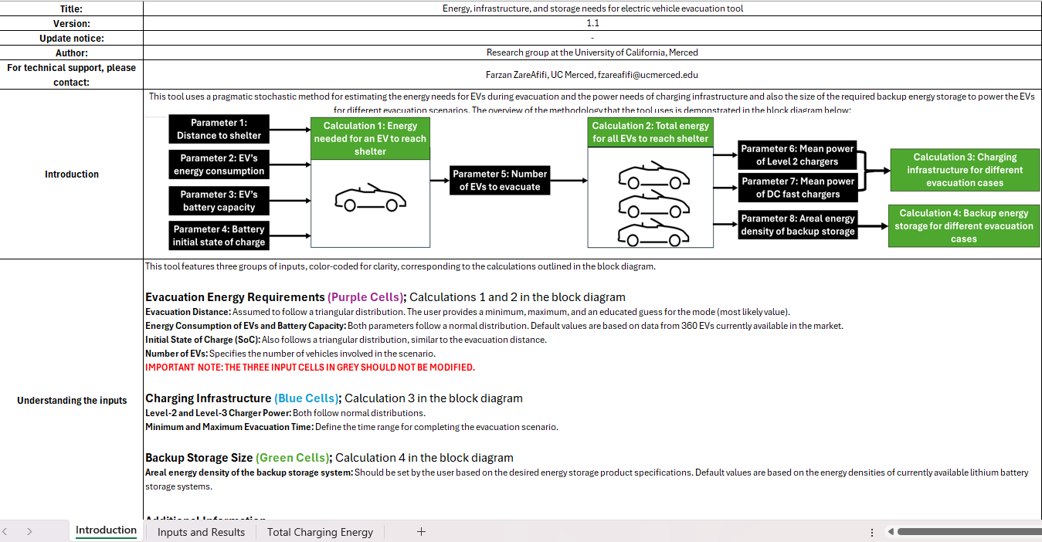
Figure 1. Screenshot of the excel worksheet to estimate charging needs during evacuations.

4. Baseline scenario
Consider a baseline scenario, where a community must evacuate 1,000 EVs because of an approaching wildfire. Residents travel different distances and begin with different battery states of charge.
Use the following baseline values, which match the attached workbook’s default inputs:

Parameter | Baseline value
Evacuation distance: minimum / most likely / maximum | 50 / 100 / 150 km
Initial state of charge: minimum / most likely / maximum | 0 / 0.5 / 1
Number of EVs | 1,000
Average EV energy consumption | 0.188 kWh/km
Average EV battery capacity | 74.4 kWh
Average Level-2 / Level-3 charger power | 6 / 80 kW
Minimum / maximum evacuation time | 4 / 8 hours
Minimum / maximum backup-storage areal energy density | 160 / 570 kWh/m²

Keep the workbook’s standard deviations unchanged. State of charge is entered as a fraction: 0.5 means 50%. The storage-density values are assumptions for this exercise; actual planning requires specifications for the selected storage system.

5. Suggested agenda
Stage | Time
Instructor introduces the scenario and tool | 10 minutes
Groups predict outcomes and run the baseline | 10 minutes
Groups investigate an assigned scenario | 15 minutes
Groups interpret results and recommend improvements | 15 minutes
Groups report findings and compare conclusions | 10 minutes
Total | 60 minutes

6. Activity instructions

Part A — Predict and run the baseline
Before running the simulation, ask participants:
- Will every EV need charging before or during evacuation? Why?
- Is total charging energy the same as the energy used by all EVs to travel to safety?
- Would shortening the evacuation window change energy needs, charging-power needs, or both?

Run the baseline and record:
- The mean and standard deviation of total charging energy.
- One observation from the total and individual charging-energy distributions.
- The charger combinations shown for the minimum and maximum evacuation times.
- The backup-storage area shown for the relevant vehicle-count scenario.

Record chart labels and units so results are associated with the correct scenario.

Part B — Change one condition
Assign each group one scenario. Restore the baseline before making the assigned change.
Scenario | Input change
Longer evacuation routes | Change minimum / most likely / maximum distance to 80 / 150 / 220 km.
Lower initial battery charge | Change the most likely initial state of charge from 0.5 to 0.2, keeping its minimum and maximum unchanged.
Shorter evacuation window | Change minimum / maximum evacuation time from 4 / 8 to 2 / 4 hours.
More EVs evacuating | Change the EV population from 1,000 to 2,000.
Ask groups to predict the effect before running the tool, then record the same outputs as in Part A. Because the tool is stochastic, small differences between runs may reflect sampling variation.

Part C — Interpret and recommend
Each group should discuss:
- Which outputs changed most, and did the changes match your prediction?
- What do the charger combinations suggest about using Level-2 versus Level-3 charging?
- How could charging before an emergency affect preparedness?
- If grid power were unavailable, what do the storage results suggest about backup-energy needs?
- What additional information would be needed to turn these estimates into an operational plan?
Ask each group to recommend two preparedness improvements, explain how the results support them, and identify one implementation constraint.

7. Reporting and reflection
Each group gives a brief presentation covering its input change, main result, and recommendations. Collect a one-page worksheet comparing baseline and modified results, with at least one chart or screenshot.

Final remarks:
- Reflection question: “Which would you prioritize for this community: improving initial battery charge, adding charging capacity, or providing backup energy? Under what conditions would your choice change?”
- Limitations of the tool [1]: The tool provides estimates for planning discussions. Meeting an aggregate energy requirement does not by itself establish that everyone can evacuate successfully. Charger locations, queues, road congestion, grid capacity, equipment compatibility, and access for vulnerable residents also need consideration.

Reference

[1] ZareAfifi, F., de Castro, R., and Kurtz, S. (2024). Planning for electric-vehicle evacuations: energy, infrastructure, and storage needs. IEEE Vehicle Power and Propulsion Conference (VPPC). See the UC Merced publication listing.

Participant Worksheet
Group members: ____________________________________________
Assigned scenario: _________________________________________

1. Record your assumptions
Complete the modified-scenario column. Keep all other inputs at their baseline values.
Input | Baseline | Modified scenario
Number of EVs | 1,000
Minimum evacuation distance (km) | 50
Most likely evacuation distance (km) | 100
Maximum evacuation distance (km) | 150
Minimum initial state of charge | 0
Most likely initial state of charge | 0.5
Maximum initial state of charge | 1
Minimum evacuation time (hours) | 4
Maximum evacuation time (hours) | 8

2. Predict the effects before running the tool
For each output, write increase, decrease, or little or no change, and briefly explain your prediction.
Output | Predicted change | Reason
Mean total charging energy
Variability of total charging energy
Required charging capacity
Backup-storage area for the same storage energy density

3. Record the simulation results
Use the same units and matching scenario labels when comparing results.
Output | Baseline result | Modified result | Main observation
Mean total charging energy (MWh)
Standard deviation of total charging energy (MWh)
Observation from the individual EV charging-energy distribution
Observation from the total charging-energy histogram

Did the results match your predictions? Explain any differences.

4. Compare charging-infrastructure requirements
Choose a charger combination from each relevant curve. To make the comparison easier, use the same number of Level-2 chargers in all four rows and read the corresponding Level-3 requirement.
Record approximate chart values; round required charger counts upward when proposing an installation.
Simulation | Evacuation time used (hours) | Selected Level-2 charger count | Corresponding Level-3 charger count
Baseline — minimum time
Baseline — maximum time
Modified — minimum time
Modified — maximum time

What does this comparison show about evacuation time and charging requirements?

5. Compare backup-storage area
Read the storage-area chart at the same selected areal energy density for both simulations. Identify the vehicle-count curve used.
Item | Baseline | Modified scenario
Vehicle-count curve used
Selected areal energy density (kWh/m²)
Estimated storage area (m²)
The plotted storage area is an estimate based on energy density. A complete installation may require additional space for equipment, access, and site requirements.

6. Develop preparedness recommendations
Recommend two improvements supported by your findings.
Proposed improvement | Supporting result | Implementation constraint or information needed
1.
2.

7. Prepare your group report
Question | Group response
What was your most important finding?
Which preparedness improvement would you prioritize, and why?
What important factor does this analysis leave unresolved?
What additional local data would improve the estimates?

